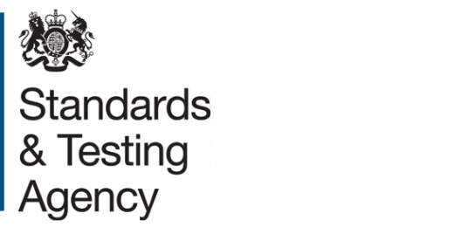

EYFS profile moderation visit template
Local authority moderators should use this template to record moderation visits to schools and other settings. A copy of the form should be given to the headteacher or manager.
Setting details
School or settings
Headteacher / manager

Visit details
Moderator name
Term/year
Date of visit
Duration of visit

Practitioner details
Name | Experience (NQT / new to reception / number of years in reception)

Moderated early learning goals
Please indicate below which early learning goal (ELG) and level of development were moderated for each profile you sampled. If practitioner judgements could not be validated, please annotate the form and record the detail in the outcomes box.

Area of learning | ELG | Aspect | Profile 1 | Profile 2 | Profile 3 | Profile 4 | Profile 5
Communication and language | 1 | Listening and attention
Communication and language | 2 | Understanding
Communication and language | 3 | Speaking
Physical development | 4 | Moving and handling
Physical development | 5 | Health and self-care
Personal, social and emotional development | 6 | Self-confidence and self-awareness
Personal, social and emotional development | 7 | Managing feelings and behaviour
Personal, social and emotional development | 8 | Making relationships
Literacy | 9 | Reading
Literacy | 10 | Writing
Mathematics | 11 | Numbers
Mathematics | 12 | Shape, space and measures
Understanding the world | 13 | People and communities
Understanding the world | 14 | The World
Understanding the world | 15 | Technology
Expressive arts and design | 16 | Exploring and using media and materials
Expressive arts and design | 17 | Being imaginative

EYFS profile judgements
Use this space to record comments against the following questions:
Are judgements consistent and accurate?
Is the evidence supporting the children’s attainment appropriate?
How does the evidence match the band descriptor?
Have you observed consistent and independent behaviour?
Is the child initiated / adult directed ratio appropriate?
Does the description of the child’s characteristics of effective learning match the child’s overall attainment?

Contributors to the process
Use this space to record comments against the following questions:
Who contributes to the children’s profiles within the school / setting?
How are the parents’ contributions valued and included within their child’s profile assessments?
How are the children’s contributions represented in the profiles?

Strengths
Use this space to record comments against the following questions:
Do practitioners’ have a thorough knowledge of the children?
How did internal / inter school moderation take place?

Agreed action points
Use this space to record any action points coming from your discussion:

Summary
Choose 1 statement to summarise the findings of the visit. Detail your decision below.
Practitioner judgements are ACCURATE, in line with EYFS profile
Practitioner judgements are NOT ACCURATE, in line with EYFS profile
Detail:

Signatures
Headteacher
Moderator
Practitioner
Practitioner

Setting’s comments on the moderation visit

LA moderation manager details

© Crown copyright 2017

